Demo - Using Hybrid Connection to Connect to On-Premises Database

Lab version: 1.0

Last updated: 1/14/2014

Estimated demo delivery time: **10 minutes**.



Contents

Overview 3

Prerequisites 3

Setup 3

Important Note 3

Exercise 1: Creating a Hybrid Connection to On-Premises Database 4

Task 1: Configure On-Premises SQL Database 4

Task 2: Creating Hybrid Connection in Azure 6

Task 3: Creating Hybrid Connection Listener On-Premises 10

Task 4: Configuring Expenses Application to use Hybrid Connection 12

Task 5: Testing the Hybrid Connection 16

Troubleshooting 17

# Overview

In this demo, we will demonstrate how to use a Hybrid Connection with the Expenses application running in Azure, such that it can connect to an on-premises database.

# Prerequisites

The following are required to complete this demo:

* [Microsoft Visual Studio 2013](http://www.visualstudio.com/en-us/downloads/download-visual-studio-vs.aspx) (tested with Update 4)
* Internet connection
* [Microsoft Azure](http://azure.microsoft.com/en-us/pricing/free-trial/) subscription
* [Microsoft SQL Server 2014 Management Studio Express](http://msdn.microsoft.com/en-us/evalcenter/dn434042.aspx)
* Expenses.Mvc codebase

# Setup

* Load and build the Expenses.Mvc solution to ensure that it builds correctly (**use the solution as it was left at the end of the demo titled “Moving Application to Azure”**).
* Deploy the database to the local instance of SQL Server:
  + Open Web.config from the Expenses.Web project and change the DefaultConnection to point to the local instance of SQL Server (should just need to change “data source” as appropriate).
  + Debug the Expenses.Web application to have the Expenses.Mvc database created automatically.
  + Use SSMS to check and make sure that the database was created.
* Log into the Microsoft Azure subscription that you will be using for demonstration.
* Install a local, default instance of SQL Express on the demonstration machine. Make sure to setup mixed mode authentication and setup a password for the ‘sa’ account. An overview of the configuration necessary can be found in this [MSDN](http://azure.microsoft.com/en-us/documentation/articles/web-sites-hybrid-connection-connect-on-premises-sql-server/) article.

# Important Note

* The steps in this demo assume that you are using the browser from the computer that will host the on-premises hybrid connection agent (we will be downloading the installer from the web).

# Exercise 1: Creating a Hybrid Connection to On-Premises Database

In this exercise, we will demonstrate how to prepare the on-premises SQL database instance for external connections, create the Hybrid Connection in Azure, install and configure the Hybrid Connection Listener on-premises, and finally configuring the Expenses ASP.NET application running in Azure to use the Hybrid Connection.

## Task 1: Configure On-Premises SQL Database

1. Connect to the local SQL database instance using SQL Server Management Studio and expand the Databases folder to note that Expenses.Mvc has already been created. It is important to note that this SQL instance is a default instance that uses a static port (default of 1433).

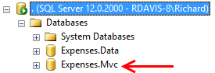

1. Right-click on the local default instance and select Properties.
2. Select the Security page and note that the “SQL Server and Windows Authentication mode” is selected.

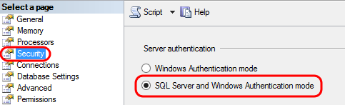

1. Select the Connections page and note that the “Allow remote connections to this server” is selected.

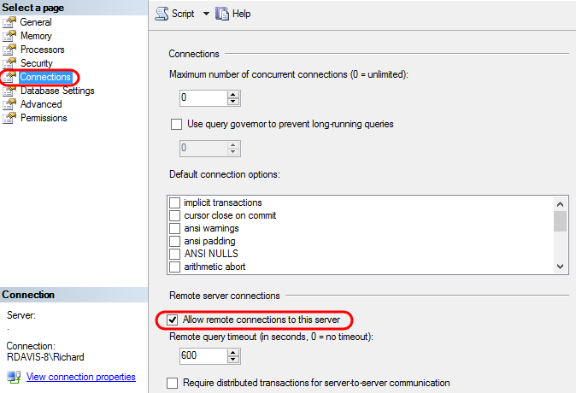

1. Close the Server Properties window.
2. Load SQL Server Configuration Manager.

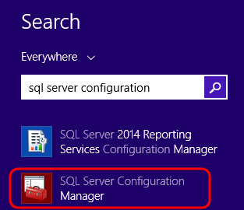

1. In the SQL Server Network Configuration, ensure that the TCP/IP protocol is set to Enabled.

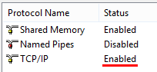

## Task 2: Creating Hybrid Connection in Azure

1. Log into the Microsoft Azure [portal](https://portal.azure.com/) and navigate to the production version of the Expenses website blade.

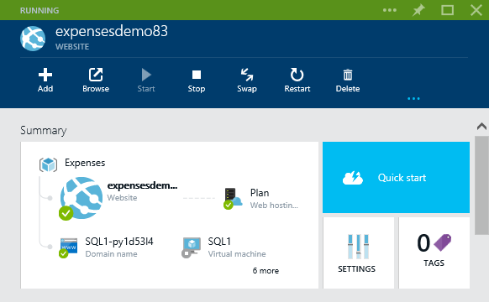

1. Scroll down to the Networking section of the website blade and then click on the Hybrid Connections tile.

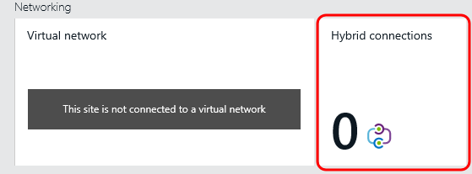

1. Click the Add button.

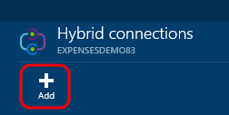

1. In the “Create hybrid connection” blade, provide a name of your choosing, e.g. “onpremdb”.
2. Next provide the Hostname of the demonstration machine where the on-premises database is installed. You can get the hostname via the Command Prompt by typing “hostname”, if needed.
3. Next provide the default Port of 1433.

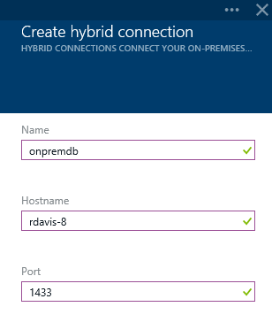

1. Assuming that BizTalk Service is not already configured, click the button to configure.



1. Provide a globally unique name for the BizTalk service.
2. Click OK.

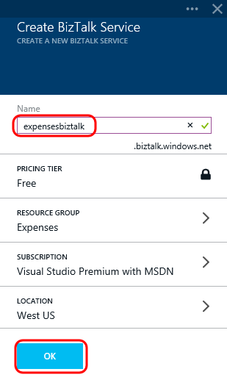

1. Click OK to create the Hybrid Connection.

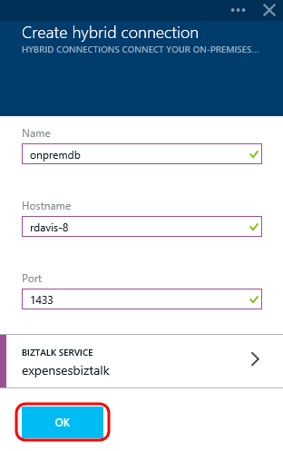

1. Wait until you receive notification that the Hybrid Connection was created (monitor the Notification Hub). This process should only take a minute.

**Note:** If you do not see a hybrid connection show up in the Hybrid Connections blade after a minute or so, check the Notification Hub for errors. One common error seen during the creation of these demos was “BizTalkServiceNameNotAvailable”. If you get that error, try to create the hybrid connection once again, this time using a different name for the BizTalk Service to be created.

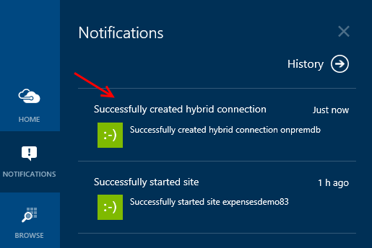

## Task 3: Creating Hybrid Connection Listener On-Premises

1. In the Hybrid Connections blade, note that the connection has a status of “not connected”.
2. Click the new hybrid connection to perform additional configuration.

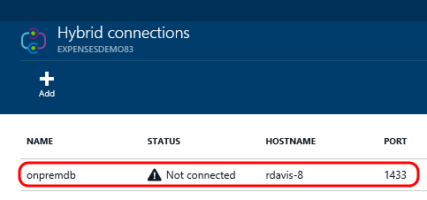

1. Click the Listener Setup button.

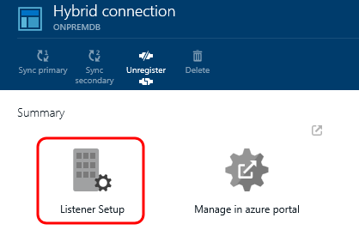

**Note:** If you see a message stating “something went wrong”, try unregistering and re-registering the connection (click Unregister button in Hybrid Connnection blade, click Add on Hybrid Connection**s** blade once again, and select existing hybrid connection).

1. Click the “Install and configure now” link and then follow the prompts to install the listener.

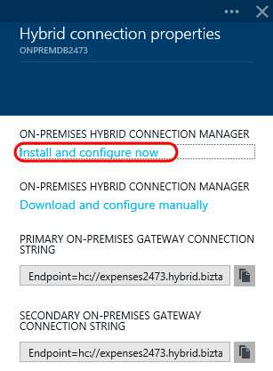

1. Once the installation of Hybrid Connection Manager is complete, click Close.

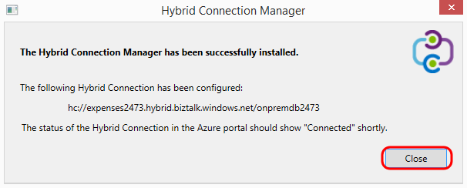

1. Back in the Azure portal, the hybrid connection should momentarily show a status of Connected.

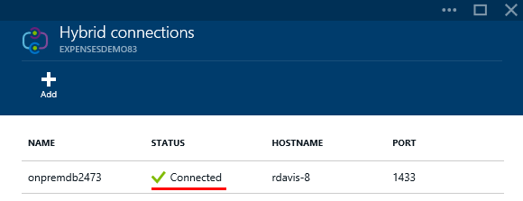

## Task 4: Configuring Expenses Application to use Hybrid Connection

1. Our first task is to construct the connection string to use when connecting from the Expenses application hosted in Azure. Thankfully this is an easy task, as we can use the same connection string that we would use from on-premises. Launch Visual Studio and open Server Explorer.
2. Right-click on the Data Connections node and select the Add Connection option.

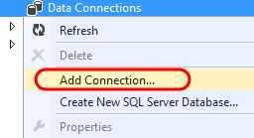

1. In the Add Connection window, enter the hostname of the machine.
2. Select the “Use SQL Server Authentication” option to log on, providing the credentials for the ‘sa’ user.

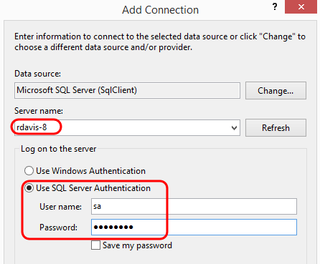

1. Select the Expenses.Mvc database and then click the Test Connection button.

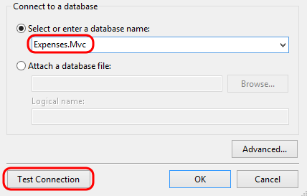

1. Click OK.
2. Assuming that your connection was a success, right-click on the connection in Server Explorer and then select the Properties option.

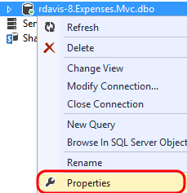

1. Copy the Connection String property to the clipboard.

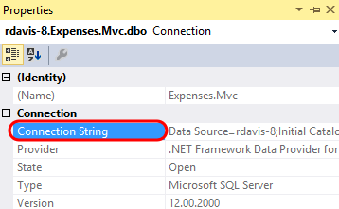

1. In Server Explorer, right-click on the data connection and select Close Connection.

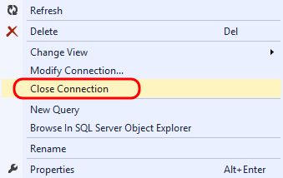

1. Back in the Azure portal, navigate to the production Website blade and then click on the Settings tile.

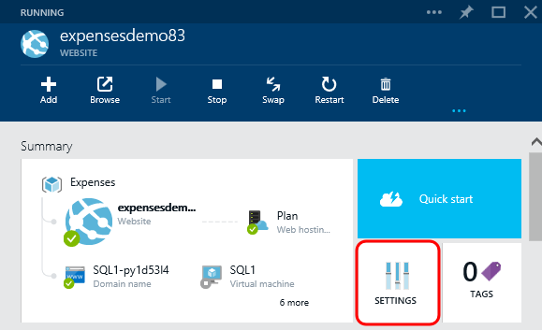

1. In the Settings blade, select the Application Settings option.

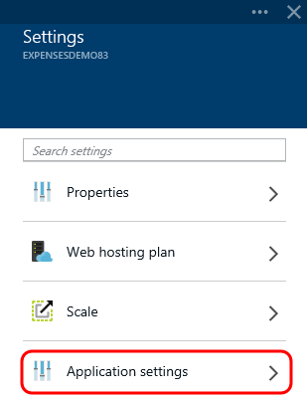

1. Click within the Value field for the DefaultConnection connection string.

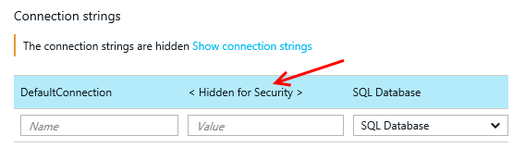

1. Press Ctrl + A to select all text, then press Delete to remove it.

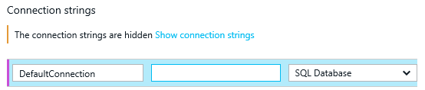

1. Paste the connection string to the on-premises database.
2. Modify the Password parameter to be the real value rather than the placeholder.
3. Click Save.

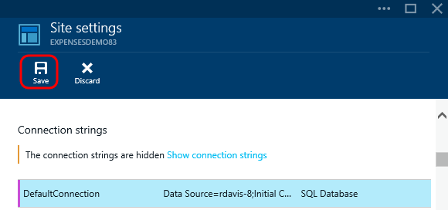

## Task 5: Testing the Hybrid Connection

1. In SQL Server Management Studio, connect to the on-premises database and modify the first Charge object represented by the first row (right-click dbo.Charges table and select Edit Top 200 Rows). In the screenshot below, we modified the Merchant property to read “On-Premises Northwind Inn”.

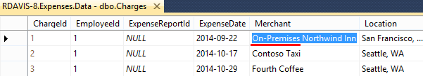

1. Click the Browse button on the production website blade in the portal to test the hybrid connection on the instance of SQL Server running on-premises.

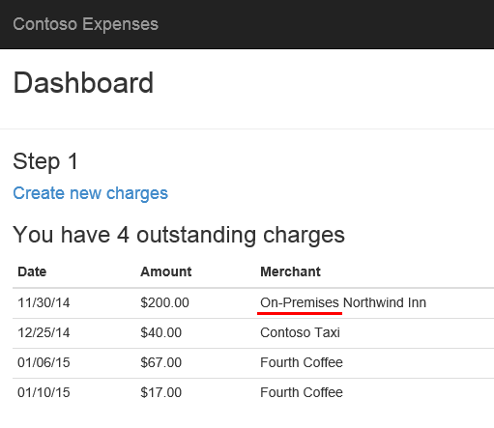

1. Close the browser window.

# Troubleshooting

In the event that you have trouble with a hybrid connection, try creating a new hybrid connection with a new unique name, un-install the Hybrid Connection Manager, and then re-install the Hybrid Connection Manager using the link provided by the new hybrid connection in the portal.